**PROJECT DEVELOPMENT PHASE-SPRINT 3**

|  |  |
| --- | --- |
| Date | 17th November 2022 |
| Team ID | PNT2022TMID30774 |
| Project Name | Personal assistance for Seniors who are self-reliant |
| Delivery | Sprint-3 |

**SPRINT 3 *-****Creating a IOT device using esp32 and notify user when the medicine time arrives.*

*.*

# 1.DEVICE SETUP

The device consists of ESP32 which is used for connecting with the ibm cloud r to publish and subscribe data. The LED glows when the medicine time arrives. The LCD displays the medicine name and the buzzer rings.

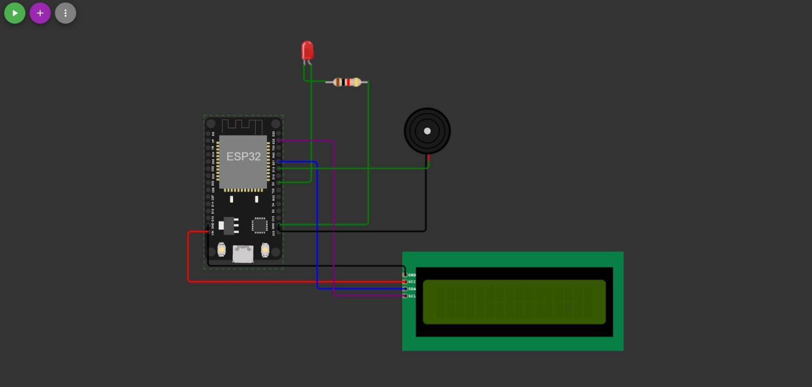

Code:

|  |
| --- |
| #include <WiFi.h>//library for wifi  #include <PubSubClient.h>//library for MQtt  #define LED 5  #include <LiquidCrystal_I2C.h> |

|  |
| --- |
| LiquidCrystal_I2C lcd(0x27,16,2);  void callback(char* subscribetopic, byte* payload, unsigned int payloadLength);  //-------credentials of IBM Accounts------  #define ORG "by18wl"//IBM ORGANITION ID  #define DEVICE_TYPE "IOT_DEVICE"//Device type mentioned in ibm watson IOT Platform  #define DEVICE_ID "12345"//Device ID mentioned in ibm watson IOT Platform  #define TOKEN "123456789" //Token String data3,light; float h, t;    #define BUZZER_PIN 19 // ESP32 GIOP21 pin connected to Buzzer's pin  //-------- Customise the above values -------- char server[] = ORG ".messaging.internetofthings.ibmcloud.com";// Server Name char publishTopic[] = "iot-2/evt/Data/fmt/json";// topic name and type of event perform and format in which data to be send  char subscribetopic[] = "iot-2/cmd/test/fmt/string";// cmd REPRESENT command type AND COMMAND IS TEST OF FORMAT STRING char authMethod[] = "use-token-auth";// authentication method char token[] = TOKEN; char clientId[] = "d:" ORG ":" DEVICE_TYPE ":" DEVICE_ID;//client id  //-----------------------------------------  WiFiClient wifiClient; // creating the instance for wificlient  PubSubClient client(server, 1883, callback ,wifiClient); //calling the predefined client id by passing parameter like server id,portand wificredential void setup()// configuring the ESP32  {  **Serial**.begin(115200);  **Serial**.begin(9600); // dht.begin(); pinMode(LED,OUTPUT); pinMode(BUZZER_PIN, OUTPUT); delay(10); lcd.init(); lcd.clear(); lcd.backlight(); **Serial**.println(); wificonnect(); mqttconnect();  } void loop()// Recursive Function  { |

|  |
| --- |
| digitalWrite(BUZZER_PIN, HIGH); delay(1000); if (!client.loop()) { mqttconnect();  }  }  void mqttconnect() {  if (!client.connected()) {  **Serial**.print("Reconnecting client to "); **Serial**.println(server);  while (!!!client.connect(clientId, authMethod, token)) { **Serial**.print("."); delay(500);  }  initManagedDevice();  **Serial**.println();  } } void wificonnect() //function defination for wificonnect {  **Serial**.println();  **Serial**.print("Connecting to ");    WiFi.begin("Wokwi-GUEST", "", 6);//passing the wifi credentials to establish the connection while (WiFi.status() != WL_CONNECTED) { delay(500);  **Serial**.print(".");  }  **Serial**.println("");  **Serial**.println("WiFi connected");  **Serial**.println("IP address: ");  **Serial**.println(WiFi.localIP());  } void initManagedDevice() {  if (client.subscribe(subscribetopic)) { **Serial**.println((subscribetopic));  **Serial**.println("subscribe to cmd OK");  } else {  **Serial**.println("subscribe to cmd FAILED");  }  } |
| void callback(char* subscribetopic, byte* payload, unsigned int payloadLength)  {    **Serial**.print("callback invoked for topic: "); **Serial**.println(subscribetopic); light=(char)payload[0]; for (int i = 1; i < payloadLength; i++) {    **Serial**.print((char)payload[i]); data3 += (char)payload[i];  }  // Make sure backlight is on      **Serial**.println("data: "+ data3); if(light=="n")  { digitalWrite(BUZZER_PIN, HIGH);    **Serial**.println(data3); digitalWrite(LED,HIGH);  // Print a message on both lines of the LCD. lcd.setCursor(2,0); //Set cursor to character 2 on line 0 lcd.print("It's time for");  lcd.setCursor(2,1); //Move cursor to character 2 on line 1 lcd.print(data3); delay(3000); digitalWrite(BUZZER_PIN, LOW); digitalWrite(LED,LOW); lcd.clear();    } else {  digitalWrite(BUZZER_PIN, LOW);  **Serial**.println(data3); digitalWrite(LED,LOW); lcd.clear();  } data3="";      } |

# 2. WEB DASHBOARD

The user can enter the medicine name, date and time when it has to be consumed which will be stored in the cloudant database and node-red checks in the cloudant database if any medicine has to be taken every minute.

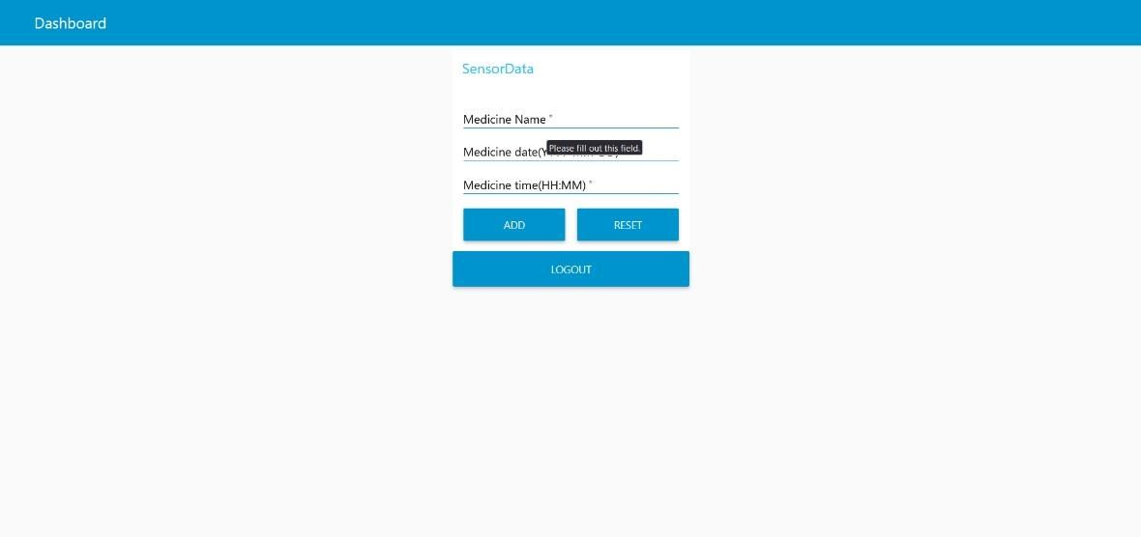

# 3. NODE-RED FLOW

When user adds a medicine into the database the node red flow keeps checking the database every minute and if a medicine has to be taken, it issues a command to the IOT device through IBM IOT Watson platform.

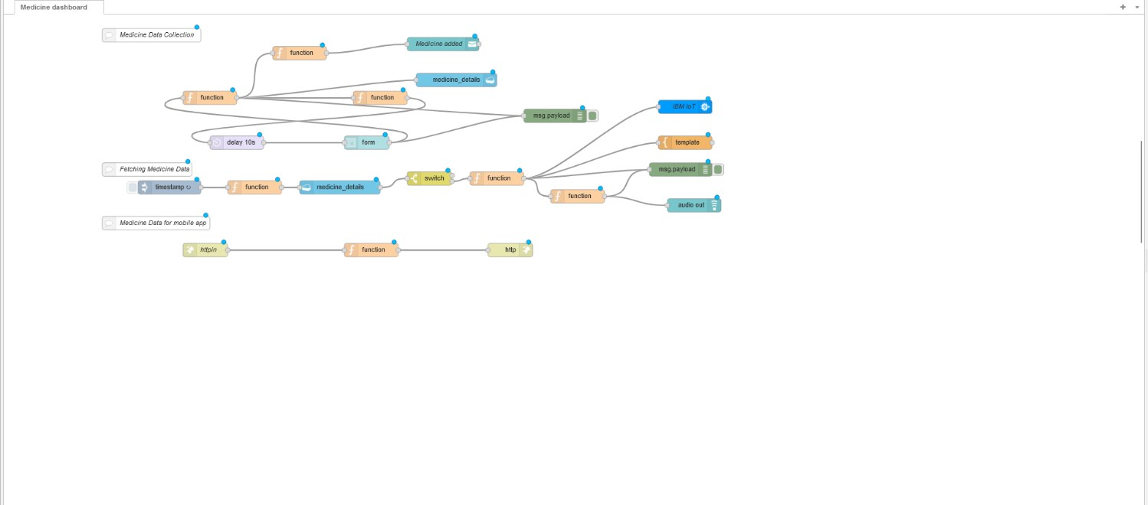

# 3. MEDICINE DATABASE

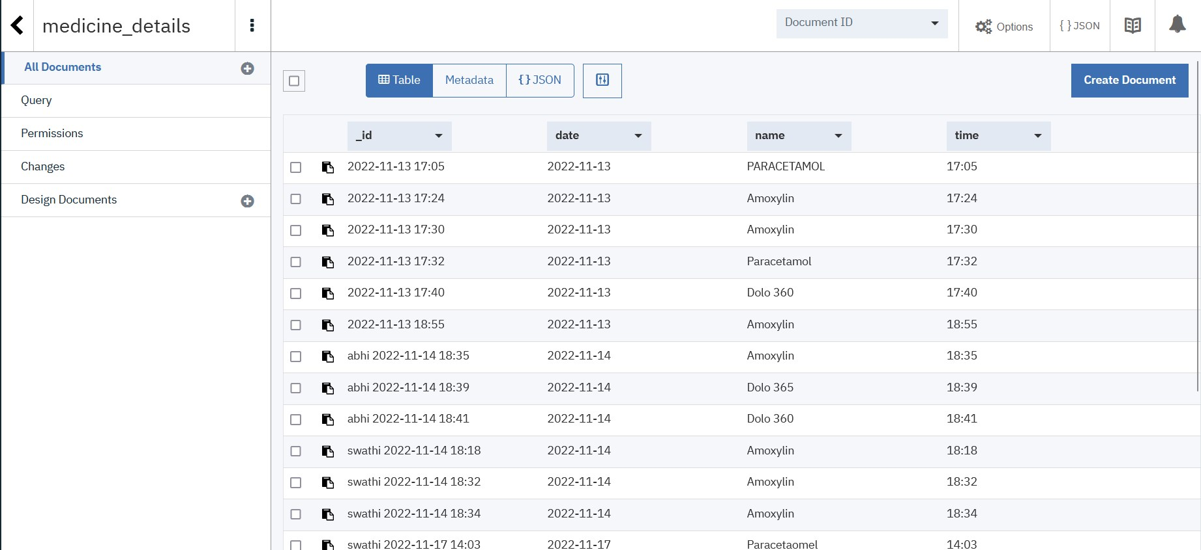

# 4. WORKING

When the medicine time arrives the node-red flow sends DEVICE COMMAND to the IBM IOT platform. ESP32 which has subscribed to the IBM IOT platform turns the LED and displays the medicine name on the LCD display on receiving the command.

## • ADDING MEDICINE

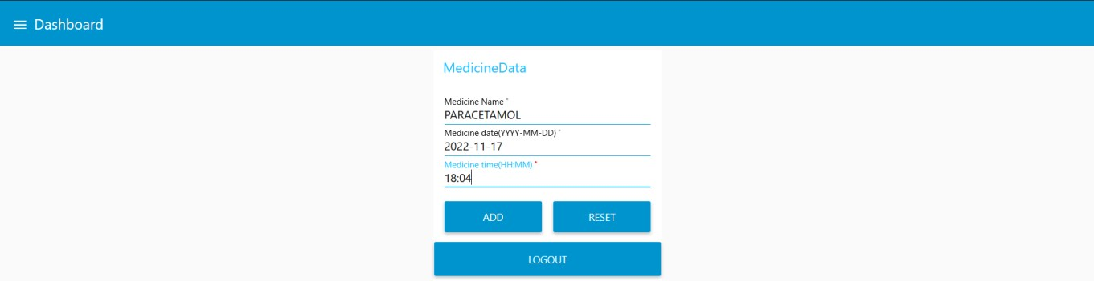

• When the medicine time arrives the LED in the device glows, LCD displays the medicine name and buzzer rings.

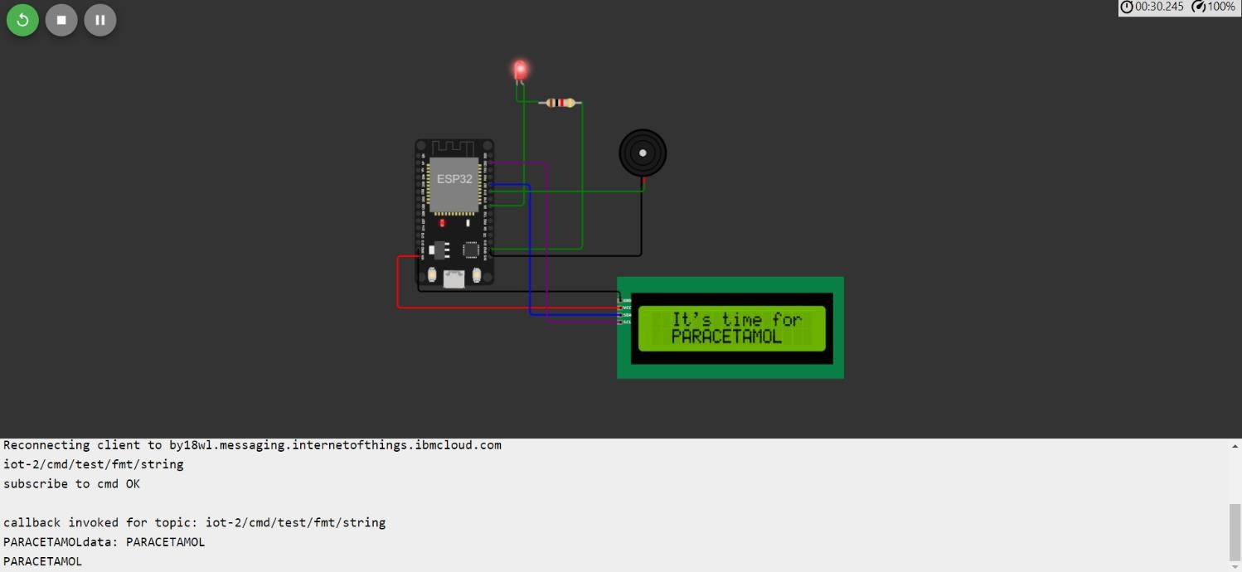

*DEVELOPMENT IN SPRINT 4: In Sprint 4, text to speech service will be implemented in the IOT device and Mobile app to monitor and control the medicine schedule will be implemented.*